This guide provides information about Zoom Breakout Rooms that you can use in your Zoom meetings and small and large group class sessions. Some content in this guide is not covered in the Zoom Breakout Rooms workshop.

Define breakout rooms (BRs) 2
Join meeting as host 2
Describe BR host capabilities 2
Assign co-hosts 2
Enable BRs in your Zoom site 3
Run BRs 3
List good practices for BRs 3
Practice BRs by yourself 3
Transfer host role 4
Prepare BRs 4
Identify BR options 4
Manage BRs 5
Describe participant capabilities 5
Identify host communication tools 5
Set up pre-assigned breakout rooms before a meeting 5
Use pre-assigned breakout rooms during a meeting 7
Describe instructional value of polls 9
Identify Zoom poll types 9
Create Zoom polls 9
Use default Zoom polls 9
Launch Zoom polls 9
Access Poll Everywhere (PE) 10
Shorten your PE username 10
Install PE 11
Create PE polls 11
Run PE polls online 11
Stop accepting responses 12
Run PE polls in PowerPoint 12
Practice polling by yourself 12
Get More Information and Support 12

Define breakout rooms (BRs)

BRs let you divide meeting participants into separate rooms

Join meeting as host
- To run BRs, you need to be the meeting host
- Log in to MyAccess then click Zoom near the bottom and log in to the Zoom site (see video)
Note: If you don’t see Zoom in your list of favorite MyAccess apps, click the Manage Favorites button on top
- After logging in to Zoom through MyAccess, you can start or join your meeting in two ways (the Zoom site or Outlook). To start or join your meeting from the Zoom site:
  - In the left menu of the Zoom site, click Meetings
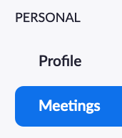
  - Find your meeting, then click the Join or Start button at the right
  - Your Zoom app will launch and you will be in your meeting
- To start or join your meeting from Outlook:
  - Find the meeting link in Outlook and click it to join or start the meeting
  - Or, you can copy-paste the link into a browser address bar to join or start the meeting

Describe BR host capabilities
Hosts can:

Add, rename, and delete BRs

Assign participants to any BR & move them to another

Join any BR, any time

Open and close BRs repeatedly

Assign co-hosts
- Co-hosts can do most of the things a host can:
  - Co-hosts can manage participants (e.g., Mute All, Rename, Remove)
  - Co-hosts can join other BRs (or host can move them to other BRs)
- In the main session, put your cursor over a participant’s name
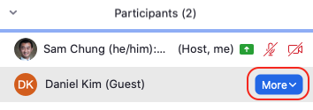
- Click More, then Make Co-host

Enable BRs in your Zoom site
For meetings created using your Zoom site, first enable BRs:
- Log in to MyAccess, then click Zoom and log in to the Zoom site
- In the left PERSONAL menu, click Settings, then enable Breakout room
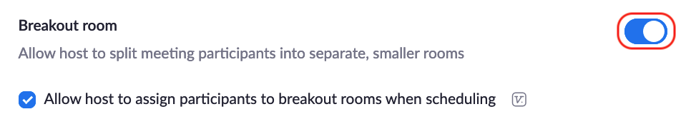

Run BRs
- This video will show you how to:
  - Prepare BRs
  - Manage BRs

List good practices for BRs
- Provide break or activity while setting up BRs (or transfer host role)
- Transfer host role to someone who can set up BRs for you
- Look out for late participants who need to be assigned to a BR
- Use shared doc or app (e.g., Box, OneNote, MS Teams) for BR activities
- Add extra BR room(s):
  - For overflow
  - For facilitators to touch-base
  - For special cases: consultations or one-on-ones

Practice BRs by yourself
- If you can’t practice with colleagues or Tas, join your own practice meeting again using a second device or computer:
  - In Zoom, create your own meeting and start it
  - Click the Invite button on the bottom of the Participants window to get your Meeting ID and meeting passcode
  - Start the Zoom app on your second device or computer
  - Click Back or Cancel as needed until you see the Join a Meeting button
  - Click the Join a Meeting button and enter your Meeting ID and Password without signing in
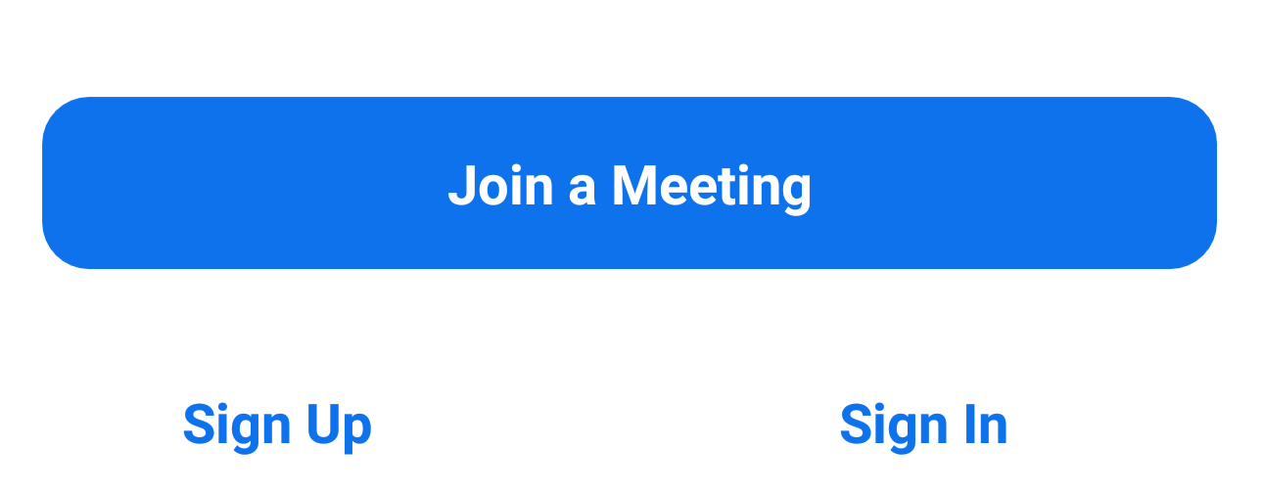
  - To prevent echo and feedback, don’t use the audio on your second device or computer
- As host, click the 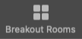 button

Transfer host role
- If you are host, in the main session, put your cursor over a participant’s name
- Click More, then Make Host

Prepare BRs
- Update your Zoom app for latest features
- If you are host, click
- Create rooms Automatically, Manually, or Let participants choose room
- Add, delete, or rename BRs if needed
- Move To, Exchange, or (Un)Assign participants

Identify BR options
- Allow participants to choose room (new!)
- Allow participants to return to the main session at any time
- Automatically move all assigned participants into breakout rooms
- Auto close breakout rooms after X minutes
  - Notify me when the time is up
- Countdown after closing breakout room
  - Set countdown timer: X seconds

Manage BRs
- Click Open All Rooms button when ready
- (Optional) Type a message and click Broadcast Message to All
- (Optional) Click Join to enter a BR

Describe participant capabilities
Participants can:
- Use Ask for Help tool to contact host (click then click 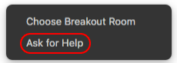 )

Return to Main Session any time (if host selects option)

Choose a BR & change BRs (if host selects option)

Interact and chat with people in their BR

Identify host communication tools
- Hosts can:
  - Broadcast messages
  - Allow participants to return to main session
  - Visit BRs periodically
  - Use external shared document
  - Use external collaboration app
  - Respond to Ask for Help tool

Set up pre-assigned breakout rooms before a meeting
Note: If host and all participants have the latest version of the Zoom app, and the host chooses the Allow participants to choose room option, pre-assigning will not be necessary. Participants will be able to choose their own room and jump between rooms anytime.
Note: You can only set up pre-assigned breakout rooms for meetings created using your own UCSF Zoom account

- Login to your UCSF Zoom account
- On the Zoom site, click Settings in the left menu
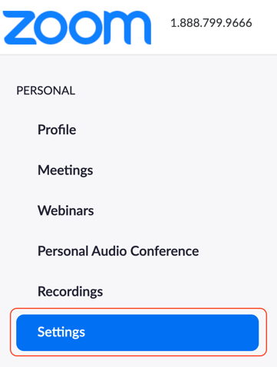
- In the In Meeting (Advanced) section of the Settings:
  - Enable Breakout room
  - Check the box next to Allow host to assign participants to breakout rooms when scheduling
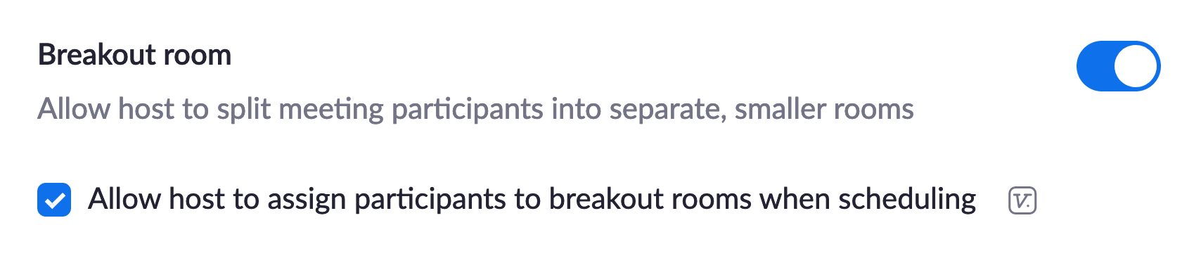
- (Optional) Enable these two settings if you want to easily identify non-UCSF participants and UCSF participants who are not logged in correctly to UCSF Zoom via MyAccess. In the In Meeting (Advanced) section of the Settings:
  - Enable Identify guest participants in the meeting/webinar
Note: If you enable this, non-UCSF participants and UCSF participants who are not logged in correctly to UCSF Zoom via MyAccess will have (Guest) next to their name in the Participants window
  - In the Security section of the Settings, enable Waiting Room and click Edit Options to edit the Waiting Room Options so that Users not in your account are placed in the waiting room
Note: You can also click Customize Waiting Room if you want to add instructions in the waiting room description
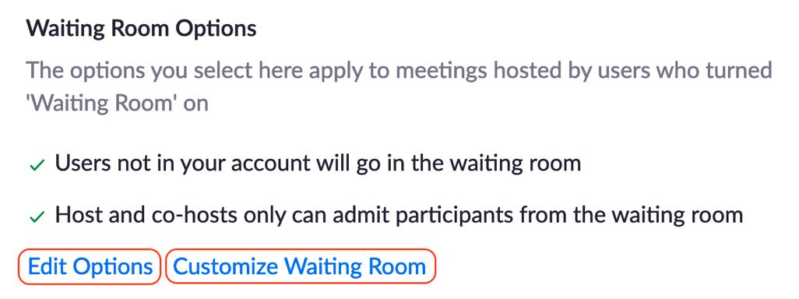
- On the Zoom site, in the left menu, click Meetings to see your list of Zoom meetings:
  - Schedule a Meeting, or edit an existing meeting that needs pre-assigned breakout rooms
- In the meeting settings:
  - Check the box next to Waiting Room to enable it for the meeting
  - Check the box next to Breakout Room pre-assign to enable it for the meeting
  - Click Create Rooms to create as many rooms as you need, and add participants one-by-one by typing their first and last name
Note: Don’t Import from CSV; add participants one-by-one instead because their UCSF email addresses must match exactly what’s in Zoom’s case-sensitive database of UCSF email addresses
Note: You can edit the pre-assignments anytime before you start the meeting

Use pre-assigned breakout rooms during a meeting
Note: If host and all participants have the latest version of the Zoom app, and the host chooses the Allow participants to choose room option, pre-assigning will not be necessary. Participants will be able to choose their own room and jump between rooms anytime.
Note: Any meeting host can use pre-assigned breakout rooms that have already been set up
- Make sure that participants logged in to their UCSF Zoom account via MyAccess before joining the meeting
Note: If necessary, ask participants to leave the meeting, log in to their UCSF Zoom account, and re-join the meeting so that the Zoom database recognizes them correctly and matches them correctly with the pre-assignments made before the meeting
- If participants are held in the waiting room, you can message them in the waiting room directly (they can’t message you back), and remind them to login via their UCSF Zoom account first
Note: Or, you can admit those participants and use Chat to ask them to leave the meeting, log in to their UCSF Zoom account, and re-join the meeting
Note: Or, you can admit those participants and later manually assign them to breakout rooms
- When you want to start setting up your breakout rooms, click the button, which only you (the host) can see
Note: Depending on the breakout room Options you choose, co-hosts and participants might only see the Breakout Rooms button after you Open All Rooms
- Manually edit the breakout rooms if needed, and assign unassigned participants (there will probably be quite a few)
Note: Make sure all co-hosts are assigned to an initial room too, so they can later join other rooms (this feature doesn’t always work, so you might need to assign co-hosts to other rooms manually)
- Click the breakout room Options to select the options you need
Note: To make it easier for participants to interact with you, consider enabling Allow participants to return to the main session at any time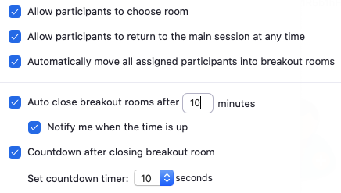
- Click Open All Rooms to start the breakout rooms
- If participants leave the meeting and return (or join the meeting late) after the breakout rooms are set up or opened, you’ll need to assign them manually, even if they were pre-assigned already before the meeting

----------- Zoom and Poll Everywhere polling -----------

Describe instructional value of polls
- Start of class: Assess prior knowledge of upcoming content
- During class: Uncover knowledge gaps to remediate
- During class: Spark discussion by exploring varying poll responses
- During class: Prompt reflection on problem/case study solutions
- End of class: Assess recall of content covered

Identify Zoom poll types
- Single Choice
- Multiple Choice

Create Zoom polls
- Log in to MyAccess, then log in to the Zoom site
- In your Zoom site personal settings, make sure Polling is enabled
- In your Meetings list, click one of your meetings
- Add, edit, or delete polls
- Note: You can only add, edit, or delete polls during your meeting if:
  - You scheduled the meeting using your Zoom site
  - AND You are the host or co-host of your meeting
- Classes in Bridges curriculum are hosted on iROCKET’s Zoom sites

Use default Zoom polls
- Zoom meetings for all Bridges classes include generic polls:
  - Multiple Choice - One Answer
  - Multiple Choice - more than one answer
  - True-False
- If you need a custom poll:
  - ask course coordinator to email iROCKET@ucsf.edu at least 1 week before class
- Create poll PowerPoint slides
  - State the poll question
  - Provide answer choices A - E or True-False

Launch Zoom polls
- Click 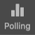
- Click 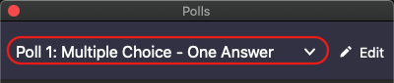 to select a poll to launch
- Click
- Click 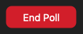
- Click

Access Poll Everywhere (PE)
- Log in to MyAccess
- Click Poll Everywhere in the list of apps
  - Click Manage Favorites if Poll Everywhere is not in your list of favorite apps
- If you have difficulty:
  - Visit UCSF Library PE site (click the SSO Account Error Fix tab)
  - or email iROCKET@UCSF.EDU

Shorten your PE username
- Go to the PE site, click the Profile icon in the lower-left
- In the Personal info section on top, select a username that is short and easy to type, then click Change
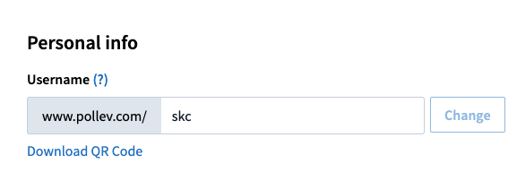

Install PE
- Download and install PE
  - Mac users: install Poll Everywhere for PowerPoint (Mac)
  - PC users: install Poll Everywhere for PowerPoint (Windows)
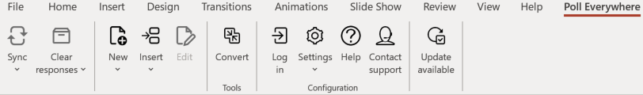

Create PE polls
- On the PE site, in the upper-left, click + Activity
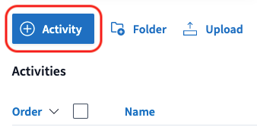
- Choose a poll type
- Add a poll title and answer options
- Click Create on the bottom-right
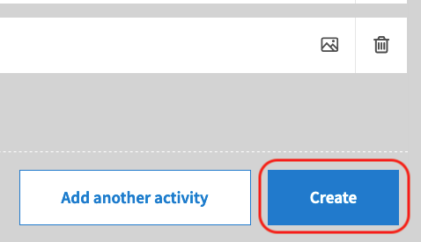

Run PE polls online
- On the PE site, click a poll in the Activities list
- In the upper-right, click Full screen, then click Activate
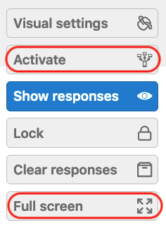
- Tell participants that poll response instructions are on top

Stop accepting responses
- Click Lock to stop accepting poll responses
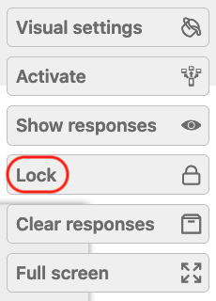

Run PE polls in PowerPoint
- Watch this video or follow the steps below to share polls via Zoom
- Download and insert your PE poll slides into PowerPoint
- (Mac only) Run the PE app in the background
- Start PowerPoint in full screen
- In Zoom, click Share Screen and share your entire screen

Practice polling by yourself
- If you can’t practice with colleagues or a TA:
- Log in to MyAccess, then the Zoom site, then start a meeting
- Get your second device or computer and run the Zoom app
- On the Zoom app, keep clicking Back until you see Join a Meeting
- Enter the Meeting ID and Passcode to join your meeting
- Use Zoom, PowerPoint, and PE to practice polling

Get More Information and Support
- To learn more about Zoom, check out Zoom’s Help Center, IT’s Zoom site, ETS’s Zoom site, the TEE Zoom Guides, the TEE Poll Everywhere site, and the TEE Remote Learning Toolkit

