This guide provides information about Zoom Polling and Poll Everywhere that you can use in your Zoom meetings and Bridges small and large group class sessions. Some content in this guide is not covered in the Zoom Polling and Poll Everywhere workshop.

Describe instructional value of polls 2
Identify Zoom poll types 2
Create Zoom polls 2
Use default Zoom polls 2
Launch Zoom polls 2
Access Poll Everywhere (PE) 3
Shorten your PE username 3
Install PE 3
Create PE polls 4
Identify PE poll types 4
Run PE polls online 4
Stop accepting responses 5
Run PE polls in PowerPoint 5
Practice polling by yourself 5
Get More Information and Support 5

Describe instructional value of polls
- Start of class: Assess prior knowledge of upcoming content
- During class: Uncover knowledge gaps to remediate
- During class: Spark discussion by exploring varying poll responses
- During class: Prompt reflection on problem/case study solutions
- End of class: Assess recall of content covered

Identify Zoom poll types
- Single Choice
- Multiple Choice

Create Zoom polls
- Log in to MyAccess, then log in to the Zoom site
- In your Zoom site personal settings, make sure Polling is enabled
- In your Meetings list, click one of your meetings
- Add, edit, or delete polls
- Note: You can only add, edit, or delete polls during your meeting if:
  - You scheduled the meeting using your Zoom site
  - AND You are the host or co-host of your meeting
- Classes in Bridges curriculum are hosted on iROCKET’s Zoom sites

Use default Zoom polls
- Zoom meetings for all Bridges classes include generic polls:
  - Multiple Choice - One Answer
  - Multiple Choice - more than one answer
  - True-False
- If you need a custom poll:
  - ask course coordinator to email iROCKET@ucsf.edu at least 1 week before class
- Create poll PowerPoint slides
  - State the poll question
  - Provide answer choices A - E or True-False

Launch Zoom polls
- Click
- Click 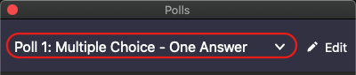 to select a poll to launch
- Click
- Click
- Click

Access Poll Everywhere (PE)
- Log in to MyAccess
- Click Poll Everywhere in the list of apps
  - Click Manage Favorites if Poll Everywhere is not in your list of favorite apps
- If you have difficulty:
  - Visit UCSF Library PE site (click the SSO Account Error Fix tab)
  - or email iROCKET@UCSF.EDU

Shorten your PE username
- Go to the PE site, click the gear in the upper-right, then click My settings
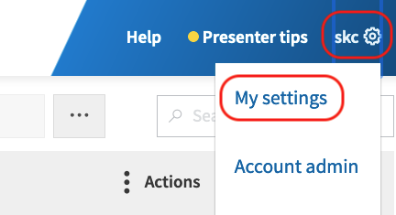
- Select a username that is short and easy to type, then click Change
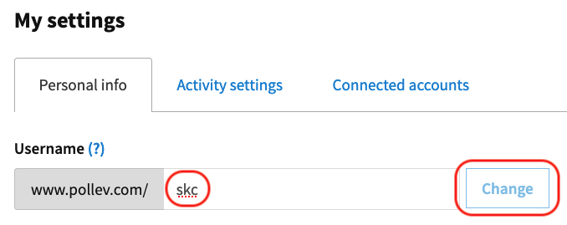

Install PE
- Download and install PE
  - Mac users: install Poll Everywhere for PowerPoint (Mac)
  - PC users: install Poll Everywhere for PowerPoint (Windows)
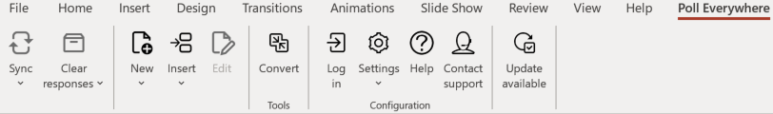

Create PE polls
- On the PE site, in the upper-left, click Create
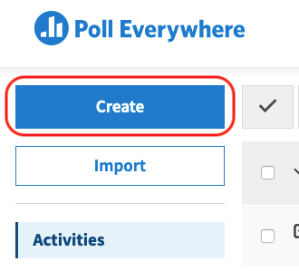
- Choose a poll type
- Add a poll title and answer options
- Click Create on the bottom-right
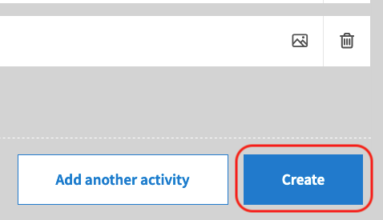

Identify PE poll types
- PE poll types include:
- Presentation feedback
- Ranking
- Clickable image
- 2x2 matrix
- Discussion

Run PE polls online
- On the PE site, click a poll in the Activities list
- In the upper-right, click Full screen, then click Activate
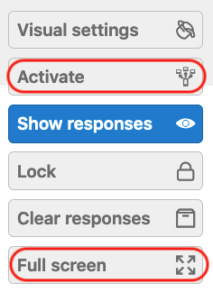
- Tell participants that poll response instructions are on top

Stop accepting responses
- Click Lock to stop accepting poll responses
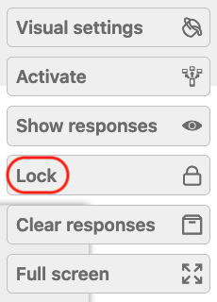

Run PE polls in PowerPoint
- Watch this video or follow the steps below to share polls via Zoom
- Download and insert your PE poll slides into PowerPoint
- (Mac only) Run the PE app in the background
- Start PowerPoint in full screen
- In Zoom, click Share Screen and share your entire screen

Practice polling by yourself
- If you can’t practice with colleagues or a TA:
- Log in to MyAccess, then the Zoom site, then start a meeting
- Get your second device or computer and run the Zoom app
- On the Zoom app, keep clicking Back until you see Join a Meeting
- Enter the Meeting ID and Passcode to join your meeting
- Use Zoom, PowerPoint, and PE to practice polling

Get More Information and Support
- To learn more about Zoom, check out Zoom’s Help Center, IT’s Zoom site, ETS’s Zoom site, the TEE Zoom Guides, the TEE Poll Everywhere site, and the TEE Remote Learning Toolkit

