This guide provides information about essential Zoom tools that you can use in your Zoom meetings and small and large group class sessions. Some content in this guide is not covered in Zoom Essentials.

Look better on video 2
Manage unreliable Internet 2
Switch audio device 2
Describe the host role 3
Join meeting as host 3
Identify things co-hosts can’t do 4
Assign roles 4
Identify Poll Everywhere polls 4
Run Poll Everywhere polls 5
Plan Poll Everywhere alternatives 5
Create Zoom polls 5
Use default Zoom polls 5
Prepare breakout rooms 6
Manage breakout rooms 6
Share computer sound 6
Share PowerPoint full screen 7
Share portion of screen 8
When to share Portion of screen 8
Practice Zoom 8
Share your PowerPoint in Presenter View 9
Manage participants 9
Manage the waiting room 10
Use whiteboard annotations 10
Use chat 11
Set up your video 11
Record your meeting and share it 11
Update the Zoom app 12
Change your Zoom profile 12
Get More Information and Support 13

Look better on video
- Your light source should shine on your face (not from a window behind you)
- Look directly into camera, eye-level
- Use an uncluttered or virtual background if possible
- Choose higher quality video settings (click the 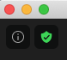 green shield in the upper-left, then click the gear icon) if needed for special video recordings (check out this TEE Zoom Guide for Pre-Recording a Lecture Using Zoom)
- Check out this TEE Zoom Guide for Presenting Yourself on Video

Manage unreliable Internet
- If your meeting participants tell you that your audio is dropping out, or that your video is slowing down or freezing, it probably means you have an unreliable Internet connection—you might see Zoom notifications about it too
- Here are some steps you can take if your Internet connection is unreliable:
  - Move your computer closer to your wireless router, or plug in to the router if possible using an Ethernet cable
  - Ask others nearby to stop using the Internet temporarily
  - Stop sharing your video
  - Ask someone else to Share Screen
  - If your audio fails, or you’re worried you might lose your Internet connection, Switch to Phone Audio
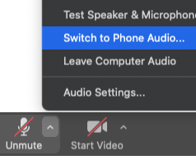
- Keep in mind that quality audio is more important than quality video

Switch audio device
- If you have a mic but no one can hear you, click the 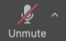 Unmute or Join Audio button at the bottom-left
Note: For the best audio, use a wired headset, earbuds, or headphones
- Do this if your mic doesn’t work, or if you can’t hear anyone talk:
  - Click the upward-pointing arrow at the right of the Mute or Unmute button to access the Audio Settings menu
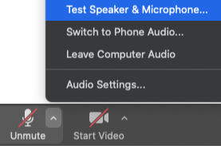
  - In the menu, click Test Speaker & Microphone
  - Follow the prompts and select a different speaker and microphone, if needed
- Do this if your audio still doesn't work:
  - Go back to the Audio Settings menu
  - Click Leave Computer Audio
  - Then click Switch to Phone Audio and call in to the meeting
- If your audio still doesn't work, re-start your computer and re-join your meeting, or use Chat to communicate

Describe the host role
- Click the Participants button on the bottom to see the host/co-host roles next to participants’ names in the Participants window
- There are only three roles in a Zoom meeting: host, co-host, and participant
- There can only be one host in each meeting
- Only the host can start and end the meeting
Note: If the host has enabled Join before host in the host’s personal Zoom meeting settings, any co-host or participant can join a meeting before the host starts it
- Only the host can promote participants to co-host, or make another participant the host
- Hosts cannot run breakout rooms on a mobile device
- To secure the host role and capabilities, log in to Zoom through MyAccess before joining a meeting though the Zoom site or a Zoom meeting link in Outlook

Join meeting as host
- Log in to MyAccess then click Zoom near the bottom and log in to the Zoom site
Note: If you don’t see Zoom in your list of favorite MyAccess apps, click the Manage Favorites button on top
- After logging in to Zoom through MyAccess, you can start or join your meeting in two ways (the Zoom site or Outlook). To start or join your meeting from the Zoom site:
  - In the left menu of the Zoom site, click Meetings
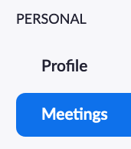
  - Find your meeting, then click the Join or Start button at the right
  - Your Zoom app will launch and you will be in your meeting
- To start or join your meeting from Outlook:
  - Find the meeting link in Outlook and click it to join or start the meeting
  - Or, you can copy-paste the link into a browser address bar to join or start the meeting

Identify things co-hosts can’t do
- Co-hosts can perform most host functions (except for starting a meeting, ending a meeting, and promoting participants to host or co-host)
- Neither a host or co-host can turn on a participant’s video—they can only request it
- You can have an unlimited number of co-hosts in each meeting
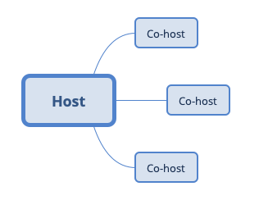

Assign roles
- Make sure you are a host
- Put your cursor over a participant's name
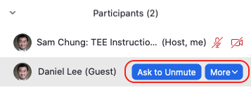
- Click the More button to Make Host or Make Co-host

Identify Poll Everywhere polls
- Poll Everywhere provides many types of polls, far more than Zoom Polling offers
- Poll Everywhere polls tend to be more visually appealing
- Some types of Poll Everywhere polls can be completed both online and via text messages

Run Poll Everywhere polls
- Get practice using Zoom and Poll Everywhere separately
- Insert some Poll Everywhere polls into PowerPoint
- Start your PowerPoint in full screen view
- In Zoom, click Share Screen and share your entire screen (not the PowerPoint app)
- If participants can’t see the poll, share the polls directly from the Poll Everywhere Web site
- Check out this TEE Zoom Guide on Using Poll Everywhere

Plan Poll Everywhere alternatives
- Share polls directly from the Poll Everywhere Web site
- Launch a Zoom poll
- Run a poll using Zoom’s reactions, chat, audio, or annotation tools

Create Zoom polls
- Zoom polls only offer 2 question types: single choice, multiple choice
- Hosts & co-hosts can launch and re-launch the polls and share poll results
- You can only create and edit polls for meetings that are hosted on your own Zoom account
- Before your meeting, go to your Zoom meetings site and click your meeting topic, then scroll to the bottom
- Find the Poll section and Add or Edit a poll, as needed
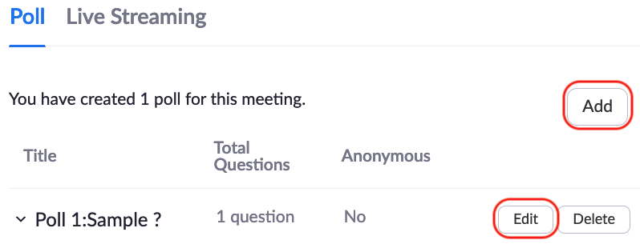

Use default Zoom polls
- For classes in the Bridges curriculum, create poll slides
  - State the poll question
  - Provide answer choices A – E or True/False
- Default poll types:
  - Multiple Choice - One Answer
  - Multiple Choice - more than one answer
  - True-False
- During the Zoom meeting, click
- Use the drop-down menu to select the poll, then click the button

Prepare breakout rooms
- For meetings hosted using your Zoom account, first enable Breakout Rooms in your Zoom personal meeting settings
- If you are the host or co-host of a meeting, click the 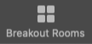 Breakout Rooms button on the bottom
- Create your rooms Automatically, Manually, or Let participants choose room
- Rename, Add Room, or Delete Room, if needed
- Check out this TEE Zoom Guide on Facilitating Breakout Rooms

Manage breakout rooms
- Move or Exchange breakout room participants, if needed (see the options next to a participant’s name)
- Assign and Unassign breakout room participants, if needed (click the Assign or participant count next to a room’s name)
- Click the gear icon on the bottom-left and make changes to breakout room options, if needed
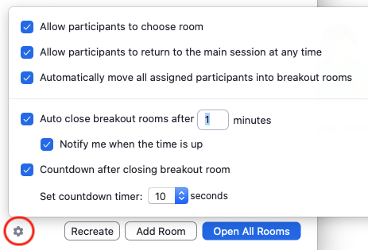
- Click the Open All Rooms button at the bottom-right to start the breakout rooms
Note: Once you Open All Rooms, you can’t rename, add, or delete rooms until you Close All Rooms

Share computer sound
- Click Share Screen
- Select the desktop or screen you want to share
- Select the 2 check boxes on the bottom left, then click the Share button
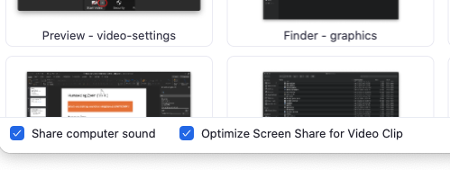
- (Macs only) Make sure ZoomAudioDevice stays selected as your computer speaker
- Ask participants if they can hear your computer sound

Share PowerPoint full screen
- To share your PowerPoint in full screen mode with meeting controls hidden:
  - Open your PowerPoint slide
  - In Zoom at the bottom, click the Share Screen button
  - Select the desktop or screen that has your PowerPoint running on it
Note: Although you can share specific apps, it’s easier to share the entire desktop so you can easily switch between and display different apps. You also need to share your entire desktop if you want your Poll Everywhere polls in PowerPoint to display correctly.
  - Click the Share button at the bottom-right
  - Run your PowerPoint in full screen mode
  - To see your meeting controls, put your cursor at the top-middle of the screen
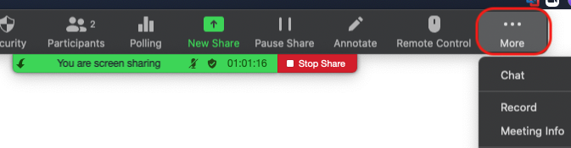
  - Some of your meeting controls will be hidden under the More menu at the right—open them as needed and move them around so you can still see your slides
Note: You will see the meeting controls, but your participants will not
- To share your full screen PowerPoint with meeting controls visible:
CAUTION: Your Poll Everywhere polls in PowerPoint will not display correctly if you select the second option Browsed by an individual (window). If you need to share Poll Everywhere polls in PowerPoint, share PowerPoint full screen instead.
  - Open your PowerPoint slide
  - In PowerPoint, click the Slide Show link on top
  - In the ribbon that appears, click 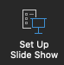 Set Up Slide Show
  - In the Show type options, select Browsed by an individual (window)
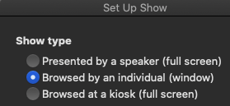
  - In Zoom, click the Share Screen button at the bottom
  - Select the desktop or screen that has PowerPoint running
  - Click Share, then share your PowerPoint in full screen by maximizing the window
Note: For more flexibility, you can also make the window large without being completely full screen

Share portion of screen
- In Zoom, click Share Screen, then on top, click the Advanced tab
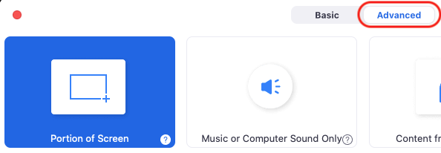
  - Select Portion of Screen, then in the lower-right corner, click the Share button
  - Move and re-size the green box to share parts of your screen

When to share Portion of screen
- Share Portion of screen when you want to:
  - Share only your slides in PowerPoint Presenter View, which allows you to still see your notes and upcoming slides
  - Quickly move between multiple open apps and windows on your desktop
  - Only share portions of a document at a time

Practice Zoom
- Check in with participants to make sure they are hearing and seeing everything you’re sharing
- Rehearse your presentations and practice Zoom with colleagues and TAs
- Join your own practice meeting again using a second device or computer:
  - In Zoom, click the Invite button on the bottom of the Participants window to get your Meeting ID and meeting passcode
  - Start the Zoom app on your second device or computer
  - Click Back or Cancel as needed until you see the Join a Meeting button
  - Click the Join a Meeting button
  - Enter your Meeting ID and Password without signing in
  - To prevent echo and feedback, don’t use the audio on your second device or computer

Share your PowerPoint in Presenter View
- Presenter View lets you see your notes and preview the next slide while presenting
- To share PowerPoint in Presenter View if you have two screens:
  - Open your PowerPoint slide and click Slide Show on top
  - (Mac) Click 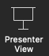 Presenter View
(PC) Check the Use Presenter View box in the ribbon
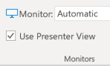
  - In Zoom, click the Share Screen button, then select the screen that has PowerPoint running full screen, not the screen with your Presenter View
  - In the lower-right corner, click the Share button
- To share PowerPoint in Presenter View if you have one screen:
  - In Zoom, click the Share Screen button, then on top, click the Advanced tab
  - Select Portion of Screen, then click Share
  - Move and re-size the green box as needed to only share the current slide in your Presenter View so your notes and upcoming slides are not visible to participants

Manage participants
- Make sure you are a host or co-host
- Put your cursor over a participant's name
- Click More to manage participants
- (Optional) Ask participants to use Nonverbal feedback tools (at bottom of Participants window)
Note: You must first enable Nonverbal feedback in your Zoom personal settings

Manage the waiting room
- First enable Waiting Room in your Zoom personal settings or in a meeting’s setup page
- You can also Enable Waiting Room during a meeting if you are a host or co-host
  - Click the Security button at the bottom and click Enable Waiting Room
- If someone enters your waiting room, you might:
  - Hear a chime
  - See a notification on the Participants button
- Click the Participants button to see the waiting participants
- To admit participants:
  - Click the Admit button to admit participants one-by-one
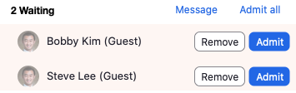
  - Click Admit all to admit all participants at once
  - (Optional) Click Message to send a message to everyone in the waiting room
Note: Check out this TEE Zoom Guide on Enabling, Disabling, and Managing the Waiting Room

Use whiteboard annotations
- At the bottom, click the Share Screen button
- Select Whiteboard, then at the bottom-right, click the Share button
- Use Zoom’s annotation tools to write or draw on the whiteboard
- To annotate, participants can click View Options on top and click Annotate
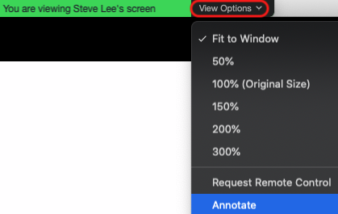
- To disable participant annotations, click More on top, then click Disable Attendee Annotation
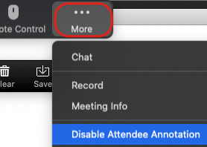

Use chat
- At the bottom, click the Chat button
- At the bottom of the Chat window, find the To: menu
- Use the To: menu to select who you want to chat with
- Enter your chat message, then click Return or Enter on your keyboard
Note: Hosts and co-hosts can change chat settings by clicking to the right of the To: menu

Set up your video
- If you have a camera, at the bottom-left, click the Start Video button
- If your video doesn’t work, follow the steps below:
  - Click the upward-pointing arrow at the right of the Start Video button
  - In the menu, select another camera in the Select a Camera list
Note: To preview how you look on camera before you Start Video, click Video Settings
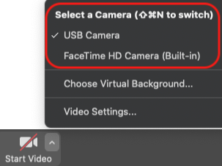
- Check out this TEE Zoom Guide for Presenting Yourself on Video
Note: If you want a Virtual Background, UCSF Communications offers some

Record your meeting and share it
- Make sure you are a host or co-host, or ask the host to give you permission to record
- Click the Record button on the bottom
- Click the Pause or Stop button as needed
Note: Every time you start and stop a recording, you will have a new recording file
- When your meeting is over, wait for your recording to convert
- Look in your Documents folder for the Zoom folder
- Open the folder that contains the meeting recordings you want to share
- The folder will contain MP4 video files, M4A audio files, and sometimes TXT chat log files
- To share your files, upload them to a shared Box or Microsoft Team or SharePoint folder
Note: Check out this TEE Zoom Guide on Pre-recording a Lecture using Zoom

Update the Zoom app
- Log in to Zoom, then start your Zoom app
- In the upper-right corner of the app, click the square
- Click Check for Updates
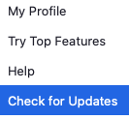

Change your Zoom profile
- The changes you make to your profile will carry over into all of your Zoom meetings:
  - Your profile name will appear in the list of participants
  - Your profile picture will appear whenever your camera is not on
- Log in to MyAccess, then log in to the Zoom site
- In the upper-left corner, click Profile
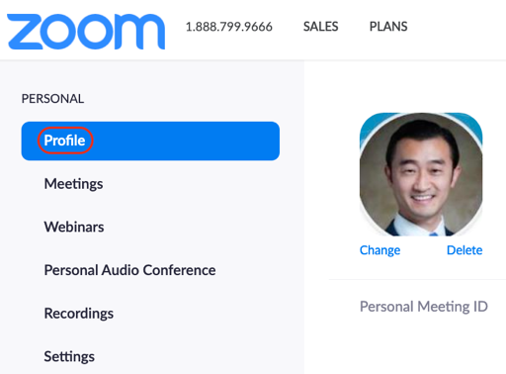
- Consider editing your profile to include your:
  - Picture
  - Pronouns
  - Preferred name
  - Job title

Get More Information and Support
- To learn more about Zoom, check out Zoom’s Help Center, IT’s Zoom site, ETS’s Zoom site, the TEE Zoom Guides, and the TEE Poll Everywhere site

